NOTICE OF COMPLETE APPLICATION
CONCERNING A PROPOSED ZONING BY-LAW AMENDMENT

TAKE NOTICE that the Council of the Corporation of the Town of Collingwood has received an application for approval of a Zoning By-law Amendment under Section 34 of the Planning Act, R.S.O. 1990, c. P. 13, as amended. This applications is deemed to be a complete submission under Section 34(10.4) of the Planning Act.

A public meeting to hear the planning merits of the application has not yet been scheduled. A further Notice specific to the public meeting will be provided in the future as per the requirements of the Planning Act.

LOCATION: The proposed Zoning By-law Amendment application (Town File No. D14320) pertains to a 0.47 hectare parcel of land legally described as Block 11, Plan 51M-926, Town of Collingwood and is municipally addressed as 31 Huron Street. The development proposal is located north and west of the Huron Street and Heritage Drive intersection and is called Collingwood Harbour House.

PLEASE NOTE: This Zoning By-law Amendment application involves a development proposal for a six storey commercial-residential building with 130 condominium apartment units and 1056 square metres of ground floor commercial. The existing Official Plan designation for this property is the Shipyards Special Policy Designation - Mixed Use which allows for commercial-residential uses in buildings of up to six storeys, up to 130 residential units and requires ground floor commercial adjacent to the Huron Street frontage. The rezoning and accompanying site plan applications propose to realize these Official Plan permissions, implementing commercial zoning with site specific provisions as necessary. Information, including the design concept for the building, can be found at the following internet link: https://www.collingwood.ca/building-business/proposed-developments/31-huron-street-project-file-numbers-d14320-application or by visiting the Town’s Land Use Planning Services webpage and clicking on the ‘see the proposed developments’ tab.

THE PURPOSE of the proposed Zoning By-law Amendment is to rezone the subject property in support of a 6 storey residential-commercial mixed use building with 1056 square metres of ground floor commercial space and 130 condominium apartment dwelling units above (storeys 2 through 6) with two levels of underground parking, surface parking and landscaped areas.

The proposed Zoning By-law Amendment would rezone the property from a Deferred Commercial (DC) Zone to a Downtown Commercial – Exception (C1-X) Zone with exception provisions to increase the maximum building height to six storeys and 26 metres, reduce the minimum rear yard setbacks to 0.0 metres and limit the number of condominium apartment units to 130.

THE EFFECT of the proposed Zoning By-law Amendment is to allow the property to be developed for the aforementioned residential-commercial mixed use building.

Please note that this land is also subject to an application for Site Plan Approval for the above-noted development proposal (Town File No. D111320).

EXISTING DESIGNATIONS:
The current Deferred Commercial (DC) Zone is an acknowledgement that commercial development of land is being deferred until Council is satisfied what the final zone classification of the lands should be and pending the enactment of an amendment to the Zoning By-law.

The property is currently designated in the Town’s Official Plan as Shipyards Special Policy Designation - Mixed Use (Shipyards, OPA No.2) which includes policies permitting commercial and residential uses in stand-alone or mixed use buildings, limiting building height to six storeys, generally limiting the number of residential dwelling units to 130 and requiring ground floor commercial along the Huron Street frontage.

ANY PERSON may attend the public meeting when scheduled and/or make written or verbal representation either in support of or in opposition to the proposed Zoning By-law Amendment.

If a person or public body would otherwise have the ability to appeal the decision of the Town of Collingwood to the Local Planning Appeal Tribunal but the person or public body does not make oral submissions at a public meeting or make written submissions to the Town of Collingwood before the By-law is passed, the person or public body is not entitled to appeal the decision.

If a person or a public body does not make oral submissions at a public meeting, or make written submissions to the Town of Collingwood before the By-law is passed, the person or public body may not be added as a party to the hearing of an appeal before the Local Planning Appeal Tribunal unless, in the opinion of the Tribunal, there are reasonable grounds to do so.

FOR MORE INFORMATION about this matter, including information about appeal rights, or to inspect additional information and materials related to the proposed zoning by-law amendment, you may contact Planning Services staff via email at: mbryan@collingwood.ca. Application details can be found at the following internet link: https://www.collingwood.ca/building-business/proposed-developments/31-huron-street-project-file-numbers-d14320-application or by visiting the Town’s Land Use Planning Services webpage and clicking on the ‘see the proposed developments’ tab where a map and list of development proposals is available.

If you wish to be notified of the decision of the Council of the Town of Collingwood on the proposed Zoning By-law Amendment you must make a written request to Ms. Sara Almas, Clerk, Town of Collingwood, P.O. Box 157, 97 Hurontario Street, Collingwood, Ontario L9Y 3Z5. Email: salmas@collingwood.ca

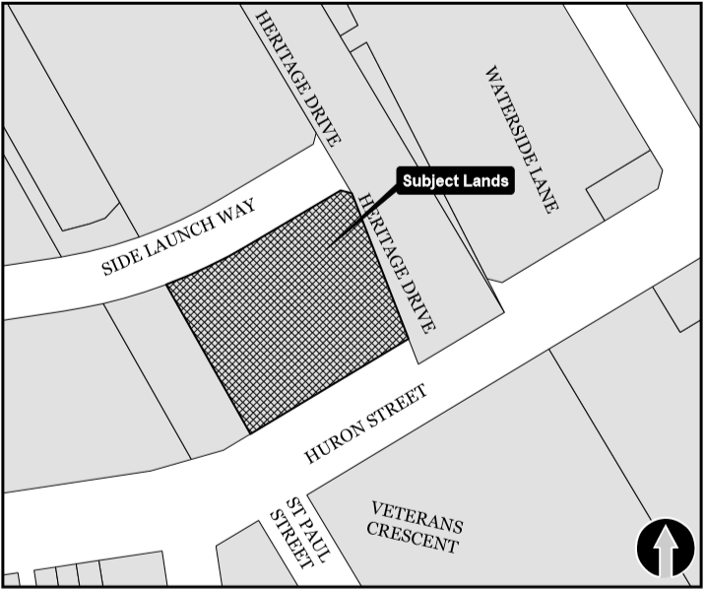
DATED at the Town of Collingwood
this 17th day of December, 2020.

______________________
Sara Almas, Clerk

Town File No. D14320

